**CTEC REPORT**

**FLAVOUR FUSION**

**AAI**

**P03**



**HAFEEZAH BINTE ABDUL KASIM**

**2201536F**

**Introduction**

In today's fast-paced world, finding the perfect recipe can be tough. As cooking enthusiasts and food lovers, we often seek new and exciting dishes, but it's not always easy to discover them. That's why I decided to create a website called Flavour Fusion that helps people find great recipes in a personalized way. By using modern cloud technologies like AWS services, such as Lambda, S3, DynamoDB, API Gateway, Lex, and more, my project aimed to make it easier for individuals to explore and enjoy new recipes and I managed to create this website which has a high degree of serverless deployment.

**Features in my website:**

**Recipes Page:**

**Description:** A central hub where users can explore a wide range of recipes.

**Functionality:** Displays a collection of recipe cards, each showcasing a different dish, including the recipe name and an enticing image.

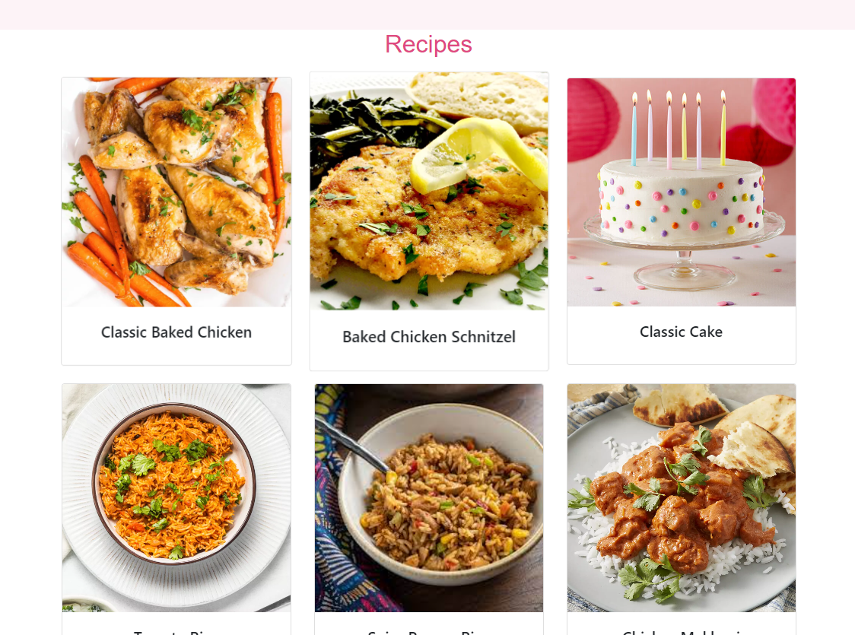

**Dropdown Categories for Filtering:**

**Description:** A user-friendly way to filter and sort recipes based on specific categories.

**Functionality**: Provides a dropdown menu with different categories (e.g., Salad, Chicken, Rice etc.) that users can select to view recipes only from that category.

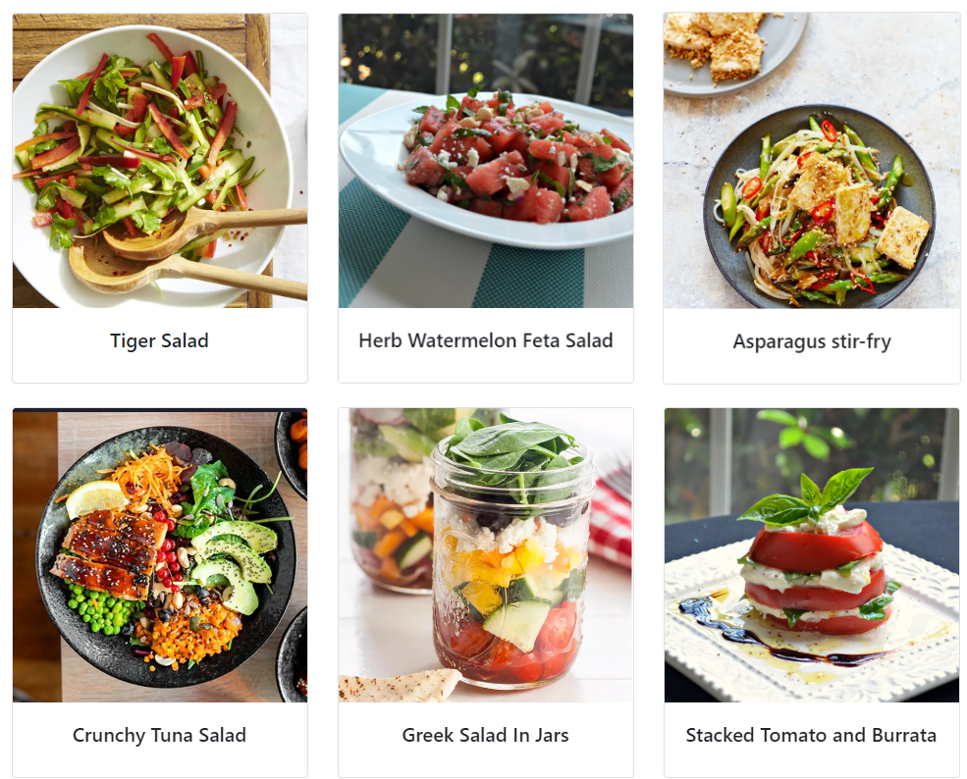

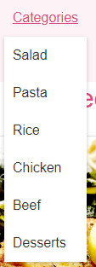

Eg. Filters only salad recipes on the left

**Search Bar Functionality:**

**Description:** Enables users to quickly search for recipes based on keywords or categories.

**Functionality:** Users can enter search queries in a search bar, and the website returns relevant recipe results based on the entered text.

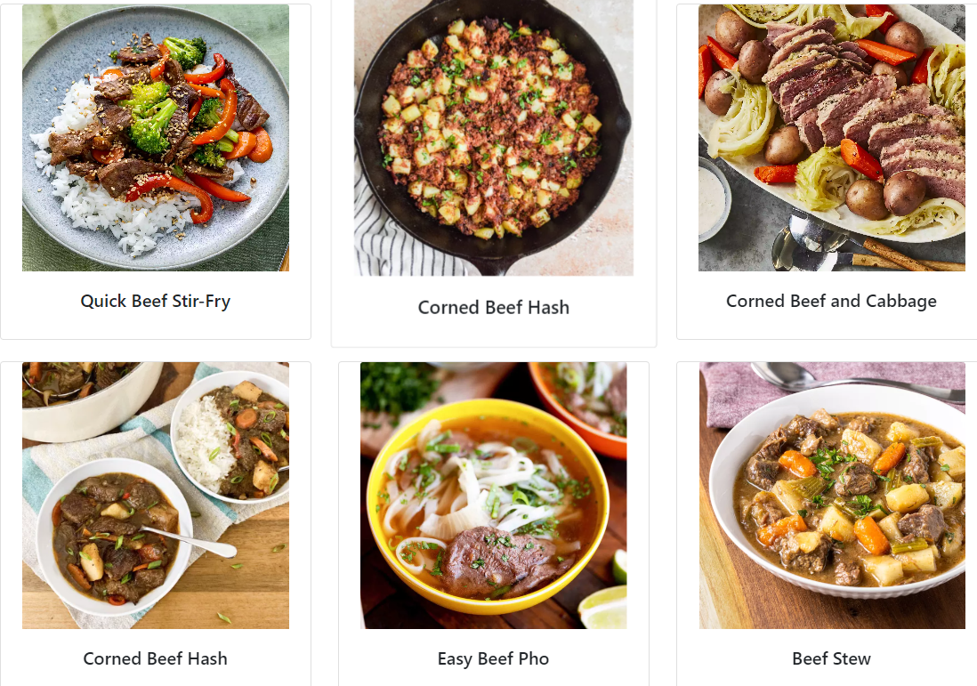

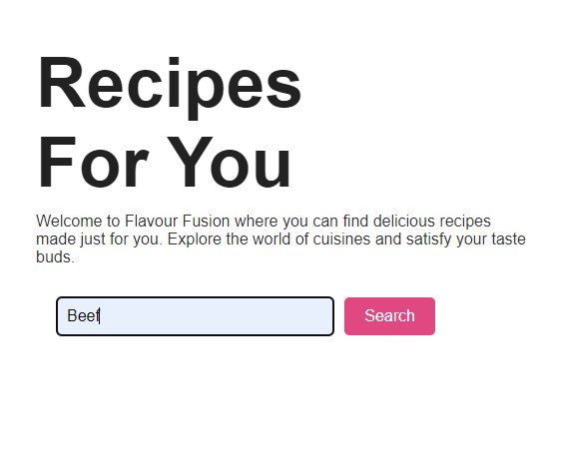

E.g. Filters and shows all beef recipes.

**Add Recipe Functionality:**

**Description:** Empowers users to contribute their own recipes to the website's collection.

**Functionality:** Users can submit new recipes by providing details such as recipe name, ingredients, instructions, cooking time, and an image.

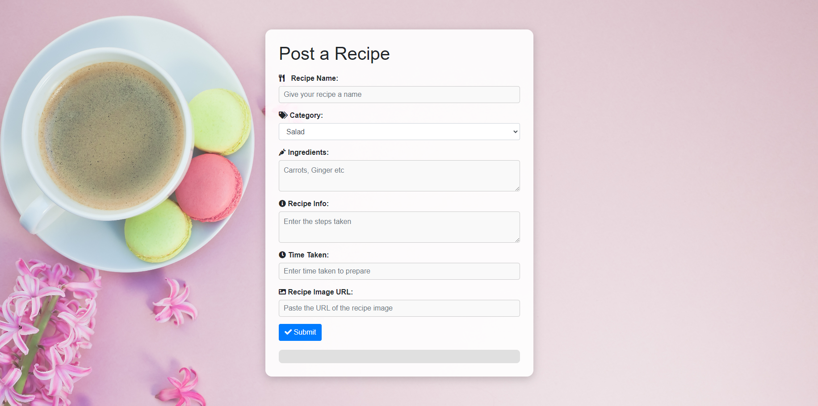

**Recipe Details in Cards:**

**Description:** Offers a detailed view of a selected recipe when a user clicks on a recipe card.

**Functionality**: Clicking on a recipe card opens a dedicated page displaying comprehensive information about the recipe, including ingredients, step-by-step instructions, cooking tips and more.

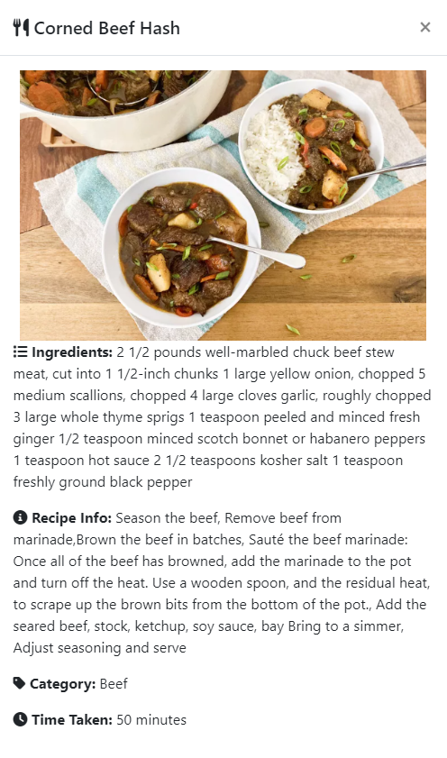

**Food Culture Section:**

**Description:** Provides insight into different culinary traditions and food cultures.

**Functionality:** Offers articles, or multimedia content that educates users about various cuisines, ingredients, cooking techniques, and cultural significance.

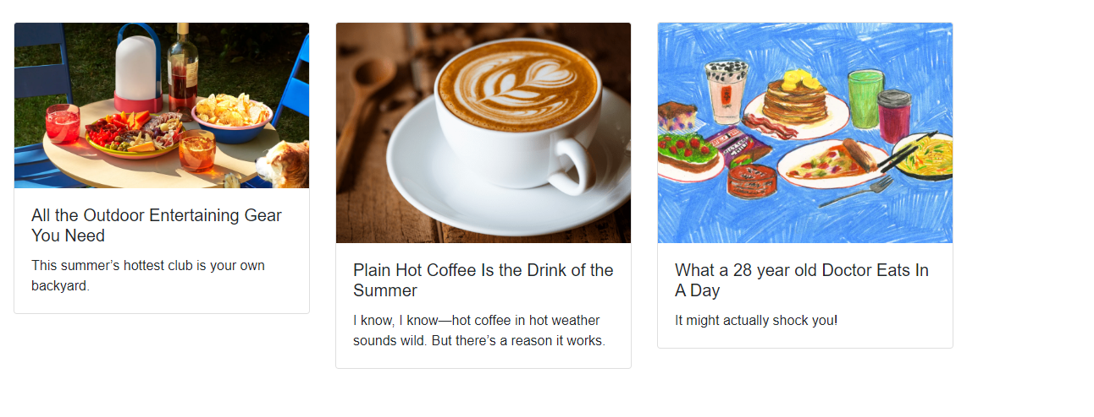

**About Us Page:**

**Description:** Introduces users to the creators and purpose of the website.

**Functionality:** Presents information about the website's mission, vision, team members, and the inspiration behind the project.

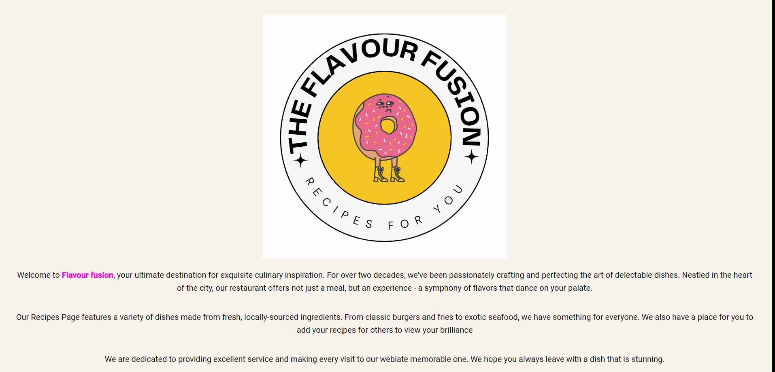

**Log In/Sign Up:**

**Description:** Allows users to create accounts and log in to access personalized features.

**Functionality:** Users can register with their email addresses, create passwords, and log in to unlock features like having access to the food culture page

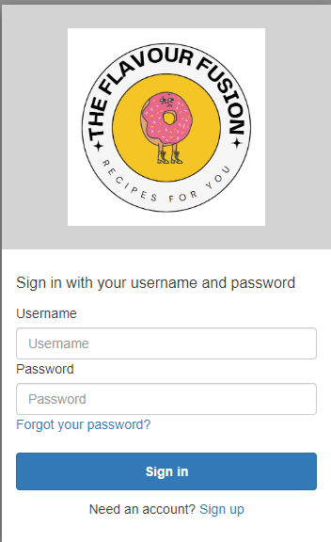

**Implementation and Use of AWS services to achieve this website:**

**Database**

To effectively manage and organize the wealth of culinary information within my recipe recommendation website, I opted to employ Amazon DynamoDB, a versatile NoSQL database service provided by AWS. DynamoDB offers a scalable and performant solution for storing and retrieving a diverse array of data, ranging from recipe details to informative articles about food culture. In DynamoDB, I created two tables 1 for recipe details and another for the food culture information.

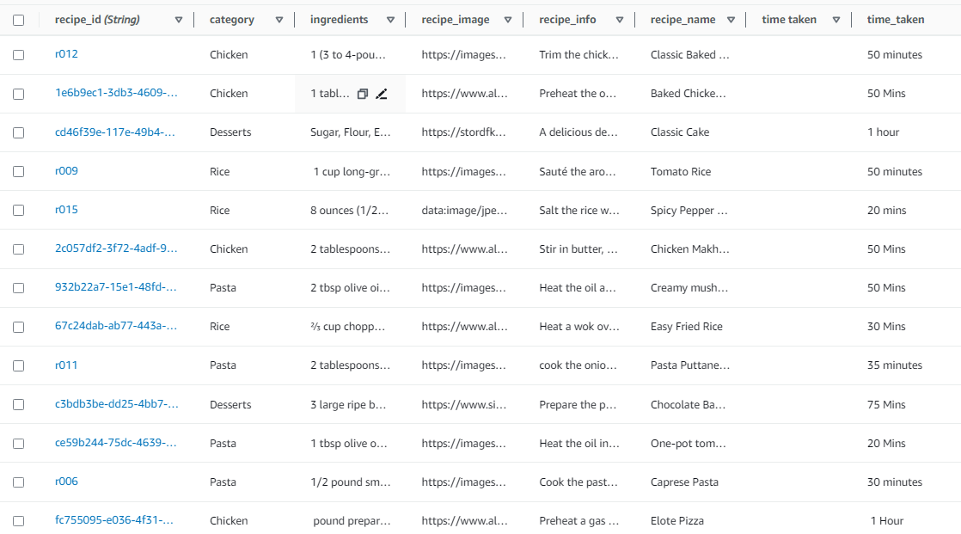

In the recipes table above, I stored the category, ingredients, recipe image, recipe information, recipe name and also the time taken to make the recipe. I also created a food culture table which stores the information of the food articles. The culture table consists of columns like culture images, the information, and the title etc.

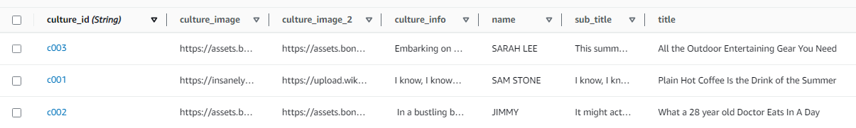

**Reasons for choosing DynamoDB:**

A reason I decided to use DynamoDB to store my website information is because DynamoDB's integration with other AWS services, such as AWS Lambda, enables seamless interaction between components of the website's backend. This integration simplifies the process of retrieving and presenting data, contributing to a smooth and efficient user journey. I also preferred DynamoDB over SQL because of its schema flexibility. Dynamo is schema-less which allows me to store different types of data in the same table without needing to define a rigid schema upfront.

**Use of AWS Lambda to write the back-end functions.**

I used AWS Lambda functions to handle important tasks like fetching recipes, applying filters, and adding new recipes. Instead of having a traditional server that handles incoming requests to fetch recipes, I’ve implemented AWS Lambda functions to perform this task.

All functions:

**Fetching recipes from table:** When a user requests a recipe, an event triggers the Lambda function, which retrieves the requested recipe from the data source which is the DynamoDB table and returns it to the user. This approach eliminates the need to maintain a dedicated server just for handling recipe retrieval, making the architecture more efficient and cost-effective.

**Applying Filters:** Similarly, Lambda functions were used to apply filters to recipes based on user preferences. For instance, if a user wants to see only Salad recipes, the Lambda function processes this filter and provide the relevant recipe list. It also accepts a search query and itll return filtered recipes based on the search term. This allows me to offload filtering logic from the main application server, reducing its complexity and enhancing scalability.

**Adding New Recipes:** When users submit new recipes, the Lambda functions handles the process of storing these recipes in the DynamoDB table. The Lambda function can validate the input, format the data, and insert it into the database.

**Getting culture articles:** When user requests culture articles an event triggers the Lambda function, which retrieves the requested articles from the data and returns it to the user.

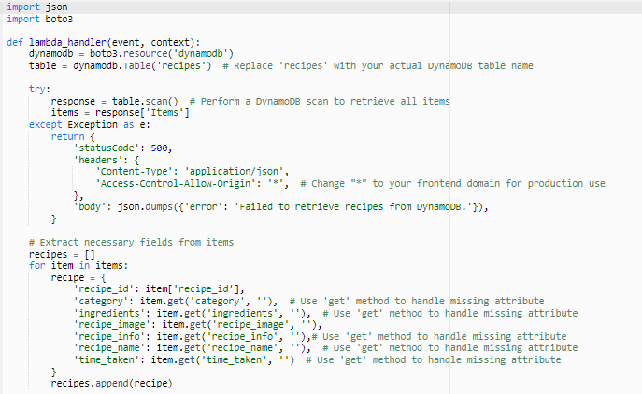

A sample snap shot of my code to scan table item and get the recipes from the recipes table. (Python)

Permissions and roles for the functions:

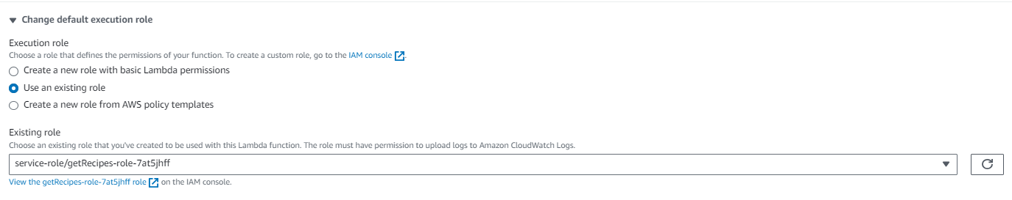

For the execution role, I used an existing role which I created under the IAM roles console. I created a role with a set of permissions as seen below.

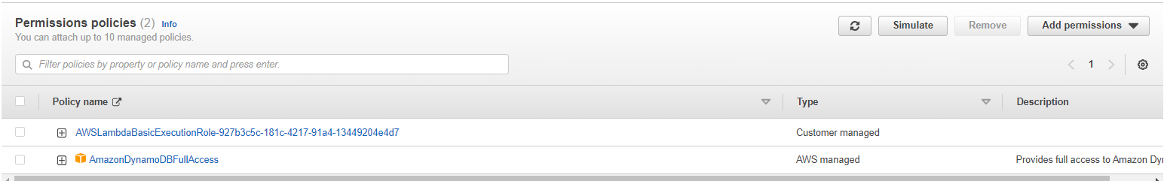

I created a getRecipes role with the permission to have access to the DynamoDB so that it can access the table and get the items needed. Using this IAM role is good practice as It enhances security.

**IAM Role**: So, this "getRecipes" IAM role I've set up acts like a permissions package that controls what my Lambda function is allowed to do with AWS resources. When I assign this role to my Lambda function, I'm essentially giving it the green light to interact with other AWS services, like DynamoDB in this case.

**Permissions for Accessing DynamoDB:** The permissions I've assigned to the "getRecipes" role are carefully tailored to enable my Lambda function to carry out operations on my DynamoDB table. These permissions might cover actions like dynamodb:GetItem, dynamodb:Query, dynamodb:Scan, and more, depending on the exact tasks my Lambda function needs to handle. These permissions are what make sure my Lambda function can smoothly retrieve recipe data from the DynamoDB table without any hiccups. It's like giving my function a special key to the DynamoDB vault so it can get what it needs. All in all, this approach helps me keep my code clean and focused on its core job, while the "getRecipes" role takes care of the security and access aspects.

Finally, I used AWS Lambda as it can easily integrate with other AWS services like Amazon APIs which I created later to create restful API’s for my lambda function enabling easy access to your recipe-related functions over HTTP.

**Use of Amazon API Gateways to create restful APIs for my lambda functions**

I leveraged Amazon APIs, specifically Amazon API Gateway, to design and deploy APIs for my Lambda functions. With API Gateway, I could define RESTful endpoints that directly map to my Lambda functions. This meant that I didn't need to manage any infrastructure or worry about scaling – API Gateway took care of that for me.

Each Lambda function that I wanted to expose as an API endpoint was integrated with API Gateway. This integration allowed incoming HTTP requests to trigger the corresponding Lambda function. For instance, when a user wanted to retrieve recipes or apply filters, they simply sent an HTTP request to the API Gateway endpoint associated with that specific Lambda function.

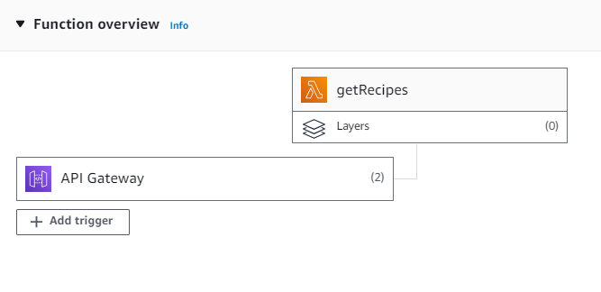

I created the APIs for all my recipe functions such as getting recipes, posting recipes, filtering etc. I created a REST API and set the following permissions.

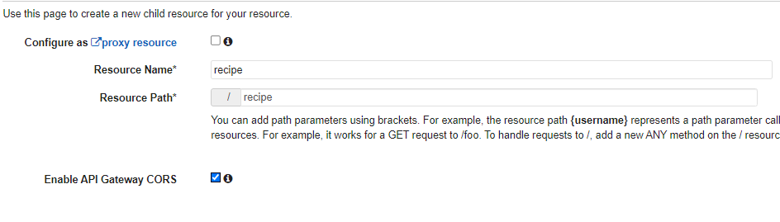

I gave it a resource name and path such as ‘/recipe’ and enabled API CORS gateway. Enabling CORS (Cross-Origin Resource Sharing) is an important step when creating APIs, especially when building a frontend application that interacts with backend APIs. CORS is a security feature implemented by web browsers to control requests made across different origins (domains). If CORS is not enabled on the API, the browser will block cross-origin requests, preventing my frontend code from accessing data from the API.

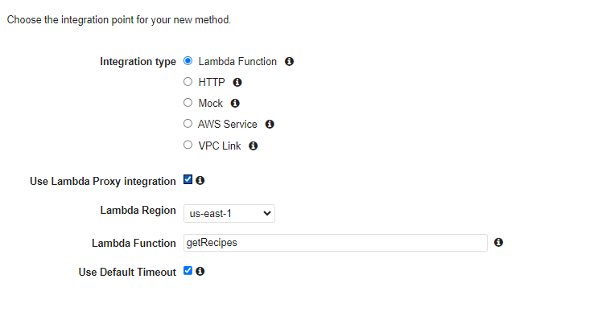

I also set the integration type as lambda function as this will allow API gateway to directly invoke the lambda function in response to the incoming API request. I finally created the method for the functions such as ‘GET’ and ‘POST’ for getting all recipes and posting recipes and deployed the API.

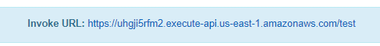

After deploying the API, I got the invoke URL which is what I would use to fetch the api to the front end.

Under the "Triggers" tab in my Lambda function, I can see the API endpoint correctly, which means that my Lambda function is integrated with an API Gateway endpoint. This integration enables my Lambda function to be triggered and execute its code in response to incoming HTTP requests made to that specific API endpoint.

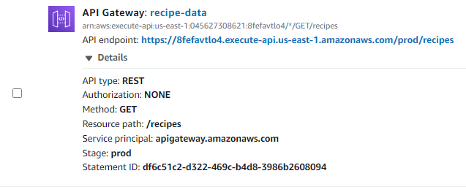

On the frontend side, I've elegantly displayed these recipes using Bootstrap cards and convenient pop-up modals. By fetching the API invoke URLs alongside the relevant resource paths, I seamlessly integrated my frontend with these powerful serverless APIs. This approach has streamlined the process of retrieving recipe data from DynamoDB. Moreover, I meticulously crafted the functions and APIs, resulting in a well-structured and efficient solution. This combination of serverless technology and thoughtful frontend design not only enhances scalability and maintenance but also provides an engaging user experience. My recipe website now boasts a sleek interface where users can effortlessly explore and enjoy the culinary delights.

Fetch all recipes and filter by category: [/recipes, /categories]

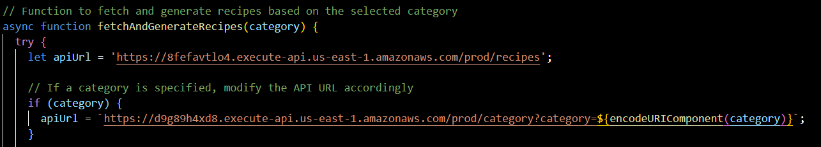

Posting recipes from the front end (form.js): I also added other validation to ensure user types in all the fields correctly. [/add]

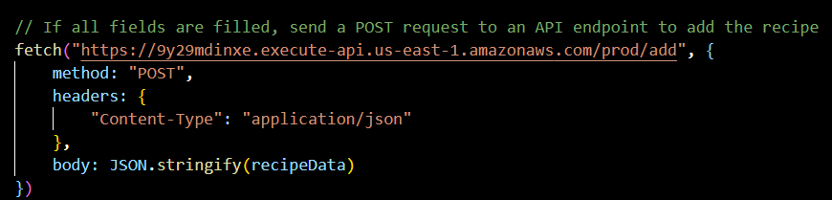

Filter based on search query: Included URL query string parameters like q (which stands for "query") in the search bar filter is a common convention used to pass search terms or criteria to APIs. For example, in the search bar on the recipe website when a user wants to search for "vegetarian," the URL query string might look like this: https://api.example.com/recipes?q=vegetarian [/search]

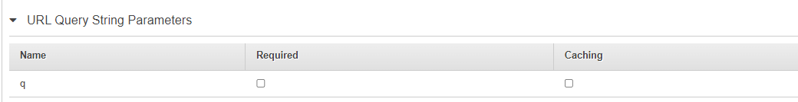

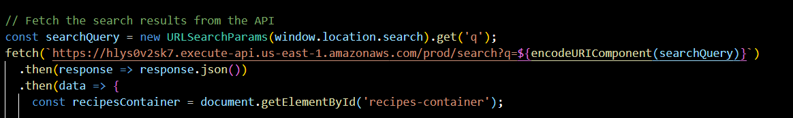

Fetch food culture articles: [/culture]

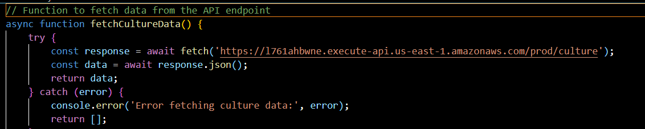

**Creating Log in function using Amazon Cognito**

I thought using Amazon Cognito to create log in and user pools is a beneficial choice for several reasons, particularly when building applications that require user authentication and management.

**Security:** Amazon Cognito provides a highly secure authentication and authorization mechanism. It follows best practices for user data protection, encryption, and authentication flows, ensuring that sensitive user information remains secure.

**User Management:** Cognito simplifies user management tasks such as user registration, login, and password reset. It offers built-in user pools that handle user identities, allowing you to focus on other aspects of my application.

**Password Policy settings:**

I used amazon Cognito defaults of the password policy mode as it was a secure way for users to create passwords that were strong.

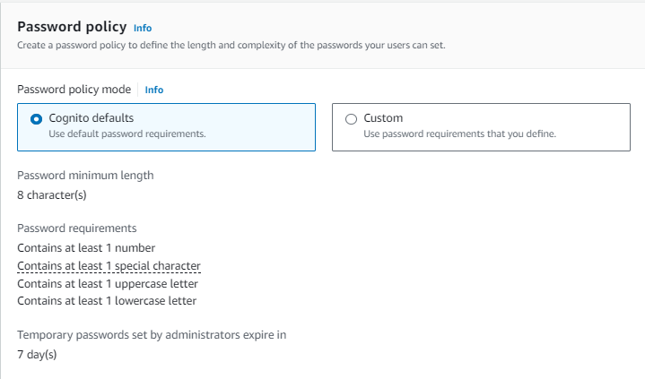

**Configure Message Delivery:**

Send verification email with Cognito.

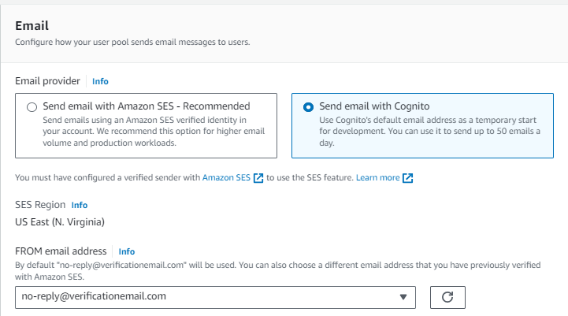

**Advanced App client settings:**

Enabling "Admin User Password Auth" in Cognito's advanced app client settings provides administrators the ability to assist users with password-related issues, enhancing user support and administrative tasks. Extending the refresh token expiration to 30 days improves user experience by reducing login frequency, while maintaining a balance between convenience and security. These settings collectively promote smoother user interactions and administrative capabilities within the application's authentication system.

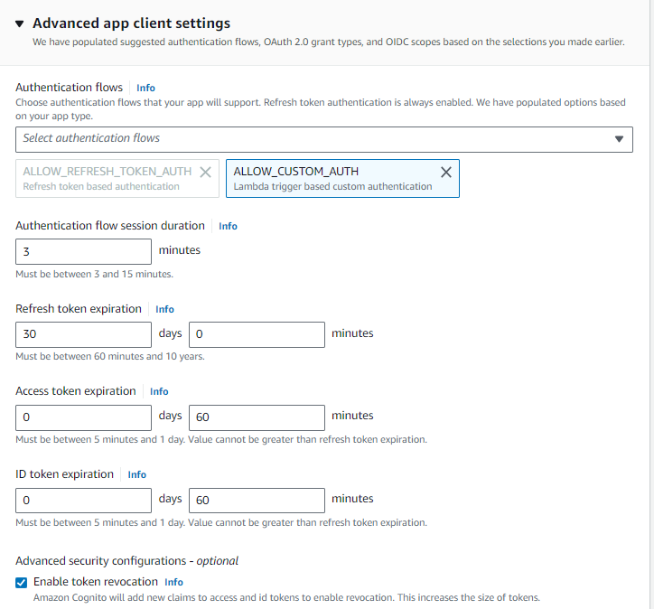

**User account recovery:** Users can recover their account using email.

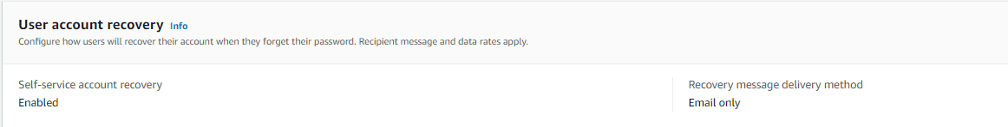

**Hosted UI and callback URL:**

I opted to employ Cognito's Hosted UI as the user interface for registration and login in my application. Additionally, I configured two callback URLs: one for successful logins and another for logging out. These URLs dictate where users are redirected upon logging in and signing out. Furthermore, I selected the implicit grant type for OAuth, which enables secure and seamless user authentication. This combination of choices streamlines the user experience, ensuring smooth navigation and interaction within the application's authentication flow.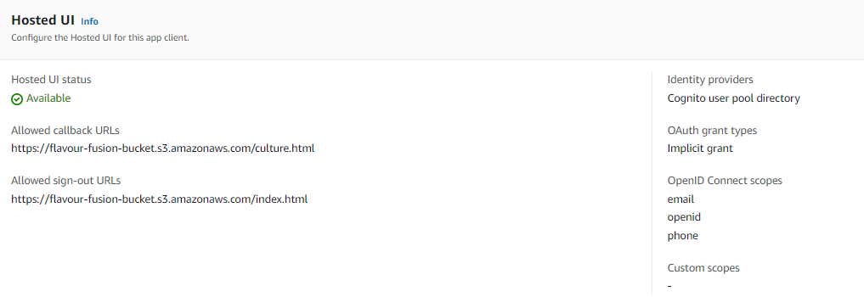

Front end:

Verify Via email

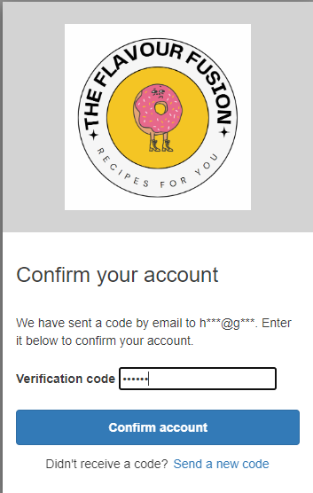

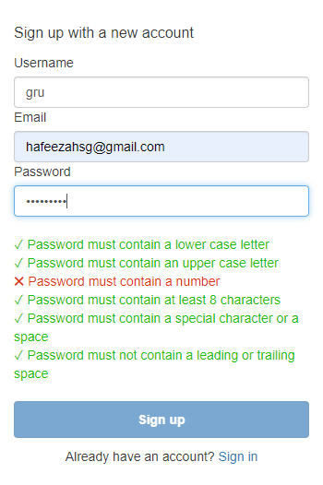

Password Restriction

Register

Log in

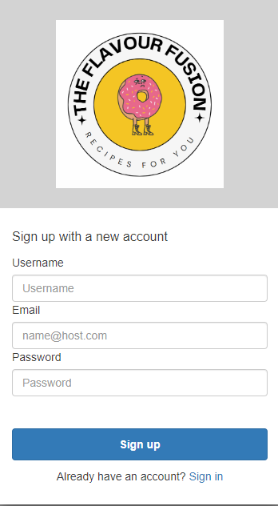

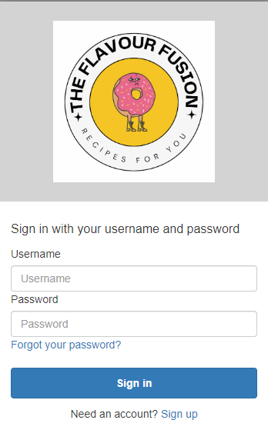

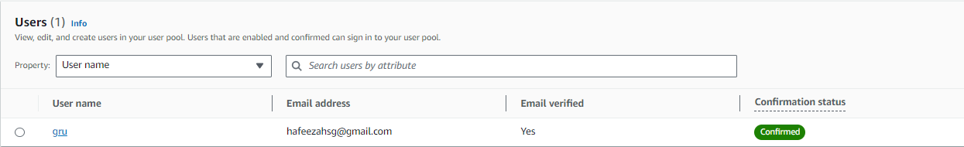

After user verifies account, they will appear under users in the Cognito user pool that was created earlier. This allows me to keep track of all the user accounts in the application.

**Implementing an AI feature with the use of Amazon LEX**

In enhancing the interactivity of my website, I decided to integrate an AI-powered chatbot using Amazon Lex. This choice stems from the desire to create a dynamic and engaging user experience. By implementing Amazon Lex, I've introduced a friendly and intuitive virtual assistant that enables users to interact with the website in a natural, conversational manner. This chatbot feature not only serves as a helpful tool for answering user queries but also adds a touch of personalization and interactivity, making the overall website navigation more fluid and user centric. By using amazon Lex’s sophisticated natural language processing abilities, it allowed me to establish the chatbot.

IAM roles:

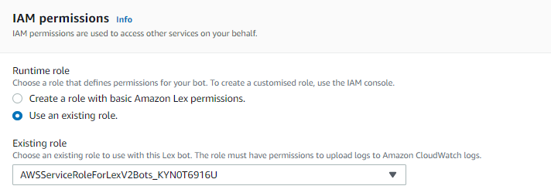

When it comes to the role for making things work, I chose to use one I made before. This role has certain rules like AmazonLexFullAccess and AmazonLexRunBotsOnly attached to it. These rules are important because they help the parts of the website you see connect smoothly with Amazon Lex. By using these rules, I make sure that the stuff you see on the website can easily talk to Amazon Lex and work together nicely.

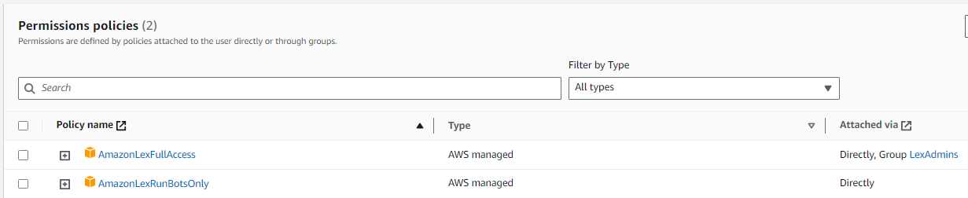

Moving forward, the next step involved constructing the bot. This entailed developing specific intents and slot types to facilitate communication between the bot and the user. The purpose of this bot is to interactively engage with the user. It will initiate a conversation, inquiring about the user's preferred recipe type, cuisine, and available cooking time. Subsequently, the bot will provide suggestions for the best recipes based on these inputs, guiding users to discover top-notch recipes within the website.

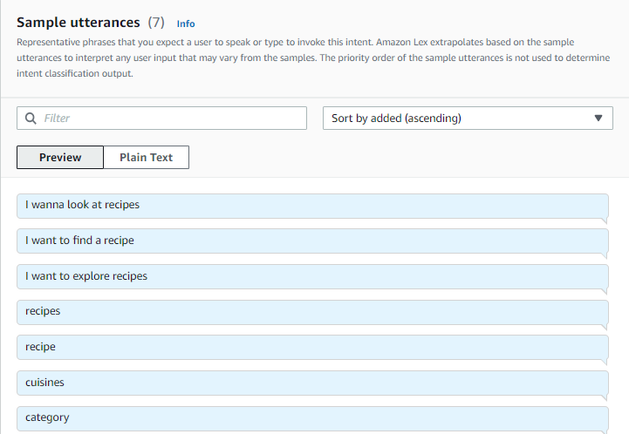

Sample utterances that the users may type in

I also created slot type values for users to type in values like timings, recipe type etc

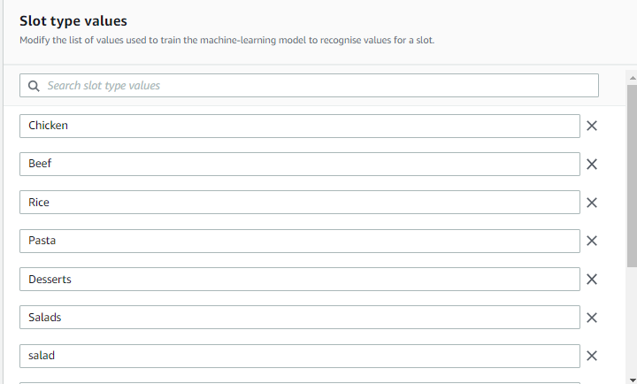

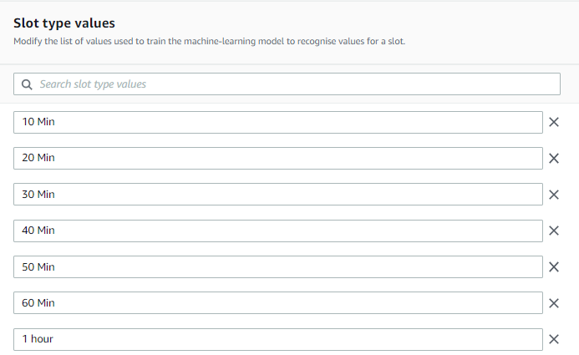

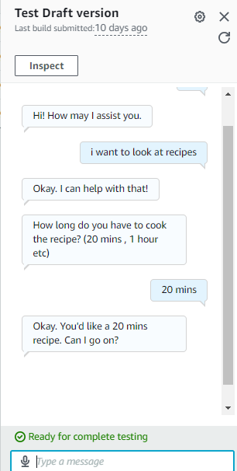

After adding the necessary intents and slot types I built the bot and tested it out in amazon before deploying it to the front end

Integration of LEX bot to front end:

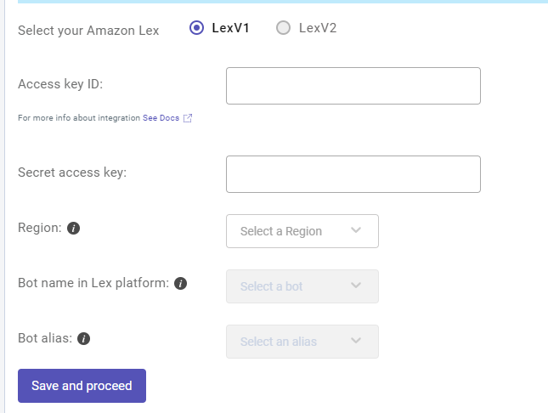

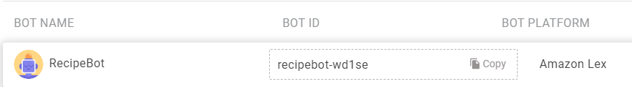

I was given an option to choose my aws bot from lex and give it a friendly icon

Expanding on the process, I proceeded to deploy the LEX bot onto the front end of the website. To achieve this integration seamlessly, I employed a third-party tool called Kommunicate. This application enabled me to connect with my Amazon LEX bots by utilizing the secret access key and ID. Through this connection, I was able to craft a straightforward and user-friendly interface for the bot, enhancing the website's interactive features. Kommunicate essentially acted as a bridge, allowing me to create an intuitive and approachable user interface that effectively communicates with the LEX bot and enriches the overall user experience on the website.

Under the Kommunicate documentation, there are codes available to install it onto the web browser. So I just put the codes into my front end files in my vscode

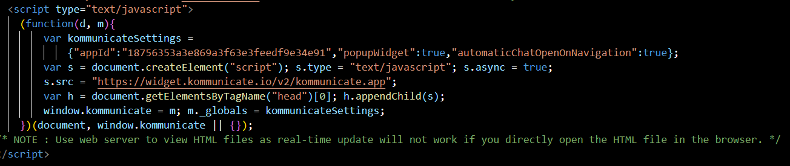

This script includes a piece of code that integrates a chatbot functionality onto the website

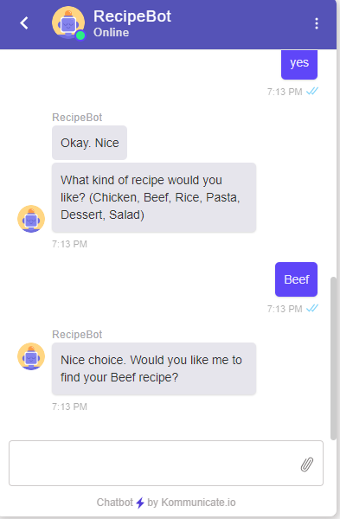

The bot will appear on the website pages at the bottom with a little chat icon where users can click to interact with the bot, adding a layer of interactivity that can assist users in finding information, answering questions, and enhancing their overall experience on the website.

**Final deployment of website on S3**

After completing the development of my website, I proceeded to upload all the frontend components, including HTML, CSS, and JavaScript codes, onto Amazon S3 (Simple Storage Service). This strategic move ensures that my website's content and functionality are securely stored and readily accessible from anywhere. By hosting these files on S3, my website gains the advantage of global distribution and scalability, allowing users from different locations to access and interact with the site seamlessly. This serverless deployment approach optimizes load times, enhances user experience, and contributes to a robust and reliable online presence.

I created a ‘flavour-fusion-bucket’ which contains all my static website files.

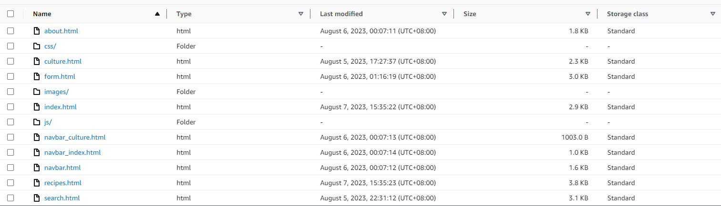

**Permissions and settings:**

By deselecting the "Block all public access" option in Amazon S3, I've enabled public access to my website's content. This decision allows people to access and view my website without any restrictions. I've ensured that all my files are publicly accessible by configuring the appropriate permissions using Amazon S3 (ASL). This step allows anyone to access and view the files that make up my website, enhancing its availability to a wider audience.

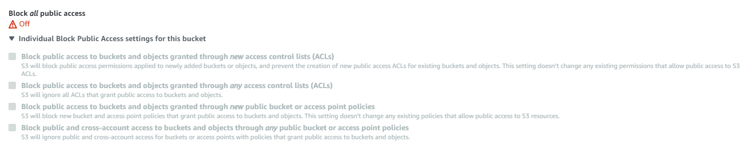

Finally static website hosting is enabled

This configuration allows my website's static files, such as HTML, CSS, and JavaScript, to be hosted and accessed directly from Amazon S3. This streamlined setup simplifies the deployment process and ensures efficient delivery of content to users, contributing to a seamless and responsive user experience.

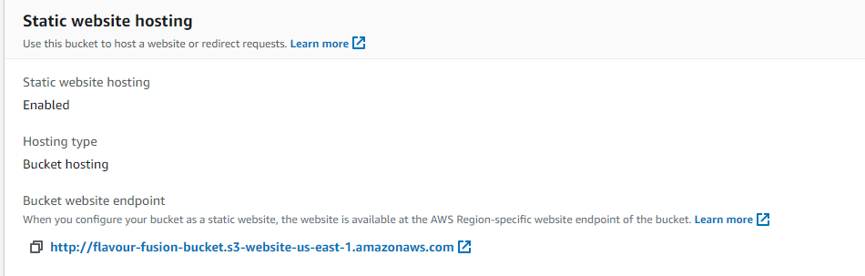

<https://flavour-fusion-bucket.s3.amazonaws.com/index.html>

**Conclusion**

The entire process I've implemented underscores the essence of a serverless architecture, where the core components of my application, including APIs, functions, and database, reside in the cloud. By leveraging services like AWS Lambda, DynamoDB, and S3, I've eliminated the need for traditional server management, provisioning, and scaling concerns.









For instance, my APIs and backend logic are executed through AWS Lambda functions, which automatically scale based on demand, ensuring optimal performance without manual intervention. Data storage and retrieval are handled by DynamoDB, a managed NoSQL database that takes care of scalability and data distribution. Even the frontend components, comprising HTML, CSS, and JavaScript, are hosted on S3, a scalable storage service, ensuring widespread availability.

This way of building my website turns it into a flexible, scalable, and cost-effective solution. I can focus on writing code and creating a smooth user experience, while AWS handles all the technical stuff in the background. This setup ensures that my website is available to users everywhere and works well. It saves resources, reduces extra work, and makes my website quick and responsive, reflecting the idea of a serverless approach.

Full list of AWS services used:

* DynamoDB
* Lambda
* API Gateway
* S3
* Cognito
* Lex